**ECEB mobile application for neonatal care**

Siddhartha Nuthakki

INFO-B 551: INDEPENDENT STUDY – Spring 2018

Faculty Advisor - Saptarshi purkayastha

School of Informatics and Computing

Indiana University Purdue University – Indianapolis, Indianapolis 46202.

**Introduction**

mHealth is revolutionizing healthcare system as a pervasive and ubiquitous technology that aids both providers and patients. While several mobile apps exist for patient education, fitness tracking, diet tracking (Wang et al., 2016) and monitoring of chronic diseases (Sobrinho et al., 2018), there are very few apps that can be used as decision support tools for nurses and clinicians to take care of neonates. Each year, globally, about 15 million babies are born too soon (premature) or too small (low birthweight small for gestational age); among these 2.7 million newborns die every year due to complications from prematurity (Every NewBorn, 2014). A common complication of prematurity and an underlying cause of neonatal death (mortality) and illness (morbidity) is the inability of small babies to maintain normal body temperature (hypothermia). To deal with such babies, the American Academy of Pediatrics (AAP) has created a decision support chart called the Essential Care for Every Baby (ECEB) Action Plan (Figure 1), by synthesizing research over a decade on helping babies survive (Essential Care for Every Baby, 2018). This program teaches health care providers essential newborn care practices to keep all babies healthy from the time of birth to discharge from the facility. Yet, the nuances of monitoring, tracking and taking care of multiple babies simultaneously in neonatal wards has a big cognitive load on nurses, who must perform tasks every few minutes on each baby. The care is divided into three phases based on the time after birth: Phase 1 (0-60min), Phase 2 (60-90min), Phase 3 (90min-24Hrs). We iteratively developed and tested the usability of the ECEB action plan, as part of the mobile Helping Babies Survive (mHBS) suite of apps, and plan to field test the app in the near future.

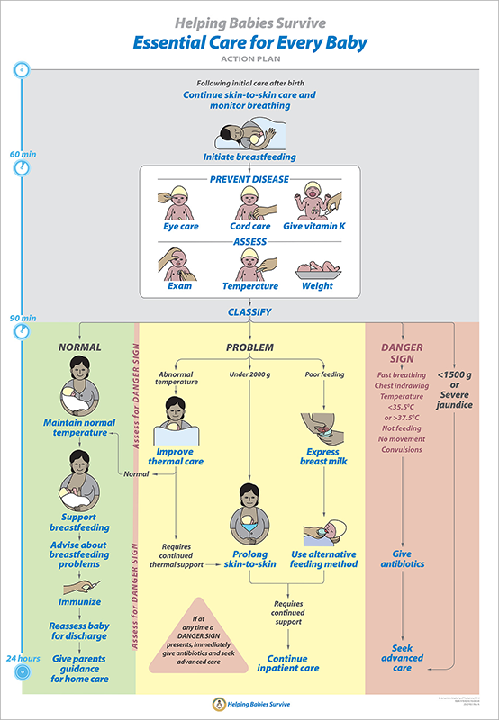

Figure 1. Essential Care for Every Baby (ECEB) Action Plan

Data about each newborn is captured using mHBS powered by District Health Information Software 2 (DHIS 2). DHIS 2 is an open-source health management information system, which is used to track health programs in over 60 countries, and by over 100 global NGOs. The ECEB app makes uses of DHIS2’s web services to login health workers and display the resources that are available in their facility. We also provided a facility login, where multiple nurses might be able to share a single tablet or phone device to manage the babies delivered at a neonatology ward. The software development was started by doing a needs analysis that was based on the already developed and successful mHBS app, which is based on other programs of the AAP. A pediatrician and pediatric researcher who was involved in designing the ECEB Action Plan for AAP was interviewed to understand the workflow and the ECEB Action Plan.

The main purpose of the project is to teach health care workers essential newborn care skills based on the condition of the baby and eventually helping babies survive. The target audience are Health care workers in resource-limited settings and aid them in training Essential care for every baby program which is based on latest WHO guidelines. The primary outcome of this study is to develop mobile application with all the required functionalities. While the secondary outcome is to train health care professionals and improve health outcomes. Resources consulted were information regarding HBB program and going through ECEB materials. Web resources regarding application development i.e., HTML, CSS, JavaScript etc.

**Workflow**

Based on the content analysis of the interview, we created wireframes of all screens, which further guided the development of the app. We selected Cordova as the framework for app development, as the developer/designer team was comfortable and well-versed with HTML/CSS and JavaScript. In order to document the care given to the baby as per the ECEB action plan, we provide a baby details registration page, which includes baby identifier, bed number, sex, mother’s name, and birth time. Once the baby is registered through the app, the healthcare provider is redirected to the different phases of the care, based on time after birth.

**Report**

A GitHub account was created to push the code as and when any updates were done in the code.

The mobile application works as follows:

1. The home page consists of Log-in and Sign-up.
2. The log in page heads to Individual or facility log in, which prompts an email and password options for logging in.
3. User need to log in with the details which are saved in the database (currently dhis2).

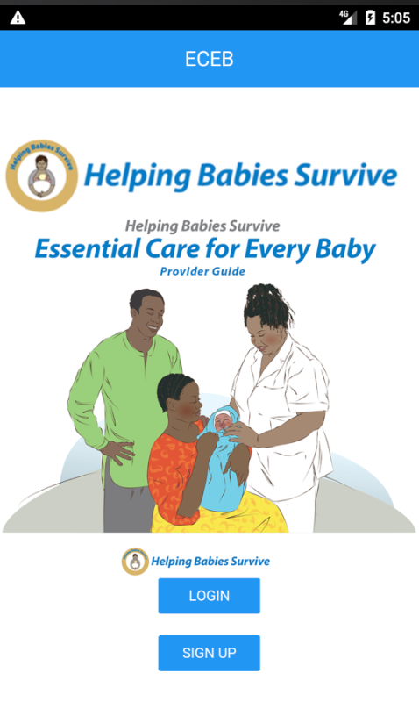 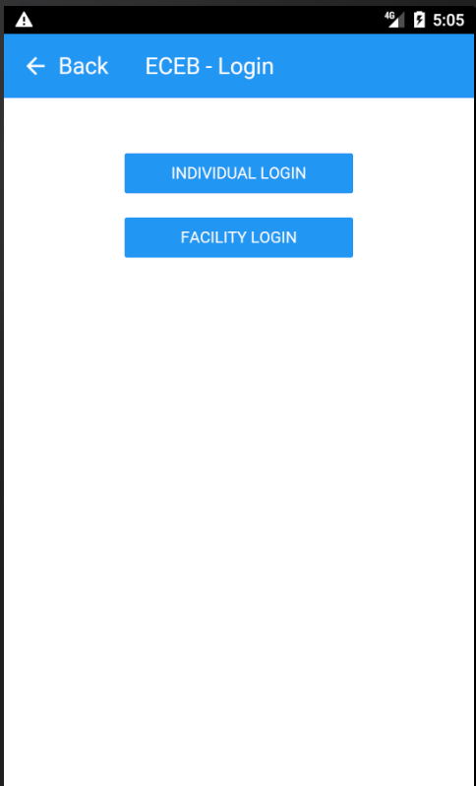 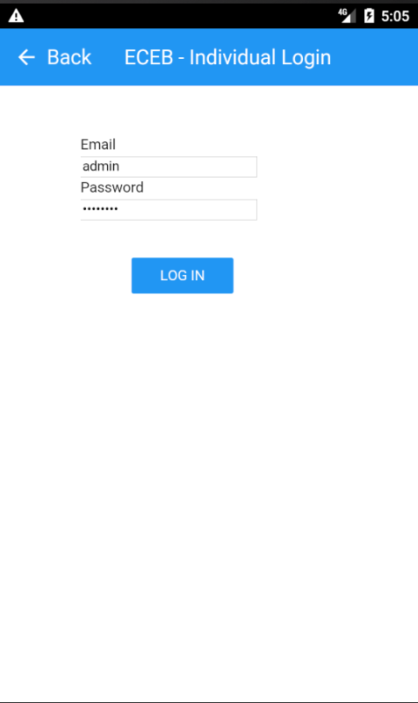

1. After logging in, the first page displays ‘Add Baby’ button, below which there were baby numbers with their mother name, and child no.
2. ‘Add Baby’ takes to baby creation page which contains Bed no., Mother name, gender, child no. and birth time.

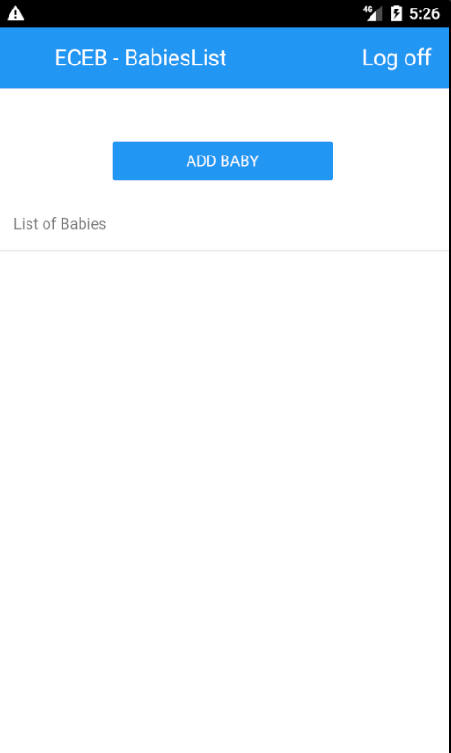 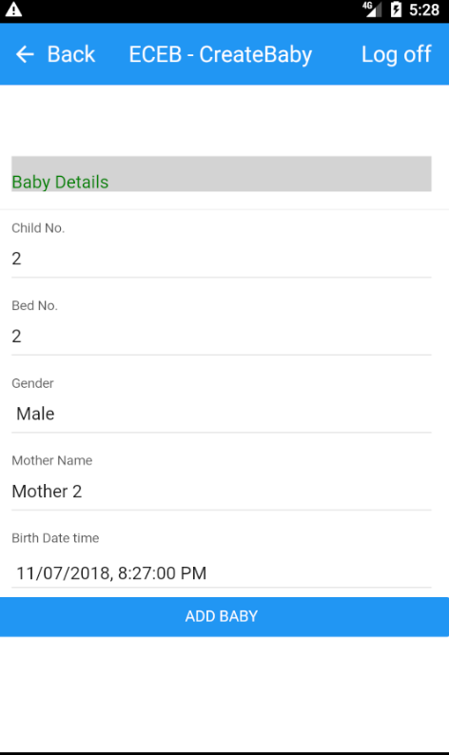 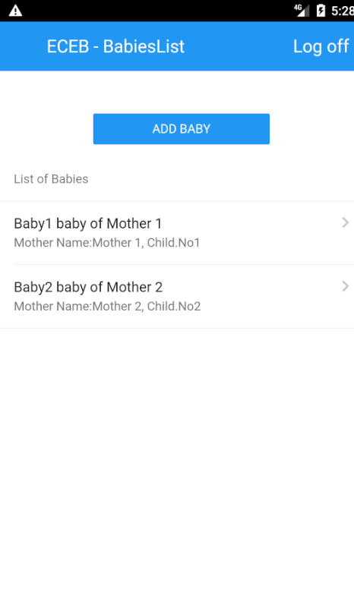

1. After adding baby, clicking on baby navigates to baby phase 1 page which is from 0 to 60 minutes of the action plan. This page contains details like the care to be given within 60 minutes of birth i.e., Skin-to-skin care, breathing monitored and breastfeeding initiated.
2. Once after the end of the 60 minutes there will be an alert asking the health practitioner to check mark what are all the treatment provided in that time frame.
3. Immediately after entering details clicking on next button saves the details entered to local storage and navigates to baby phase 2 page of the action plan which contains treatments like eye care, cord care, vitamin K, assessment, temperature and weight that should be given between 60 to 90 minutes after baby birth.
4. User will enter details as care provided to the baby or at the end of 90 minutes’ period there will be an alert asking the user to enter details of care given.

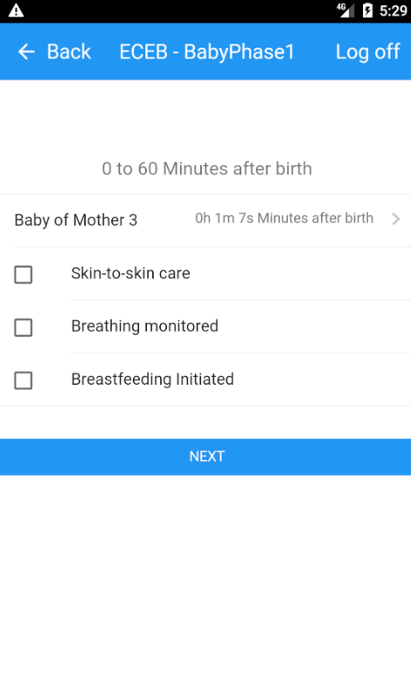 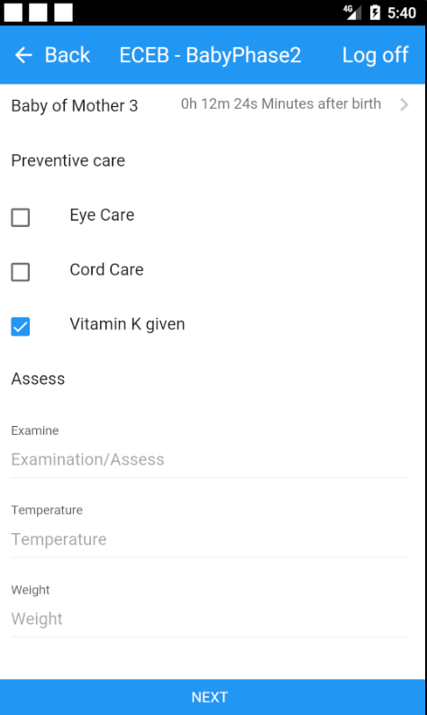 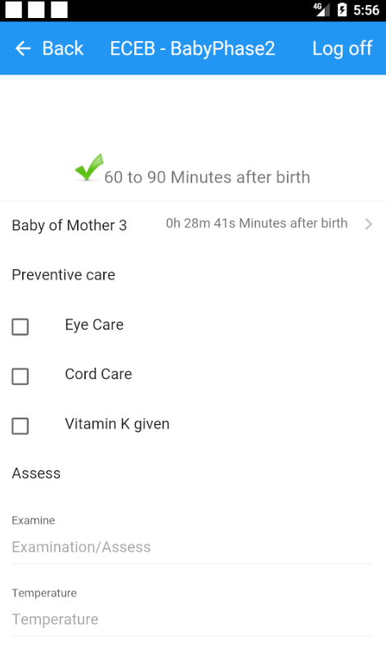

1. Based on the details entered by the user, there will be a popup of all the available options which will be showed after clicking next button.
2. The available options are Normal, Problem (abnormal temperature, under 2000g, poor feeding) and Danger sign (fast breathing/chest indrawing etc.., or <1500g or severe jaundice) of the action plan which are in phase3 of the baby care (90 minutes to 24 hours after birth).
3. Based on the assessment in phase2, the healthcare practitioner navigates to either of the pages depending on the baby condition.

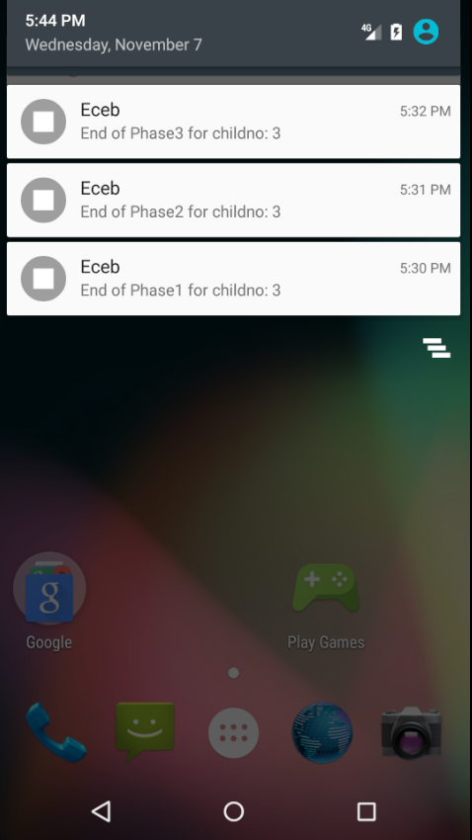 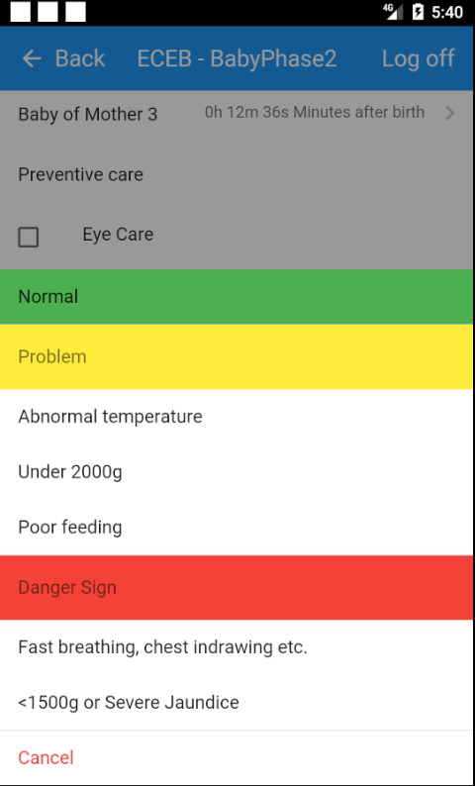 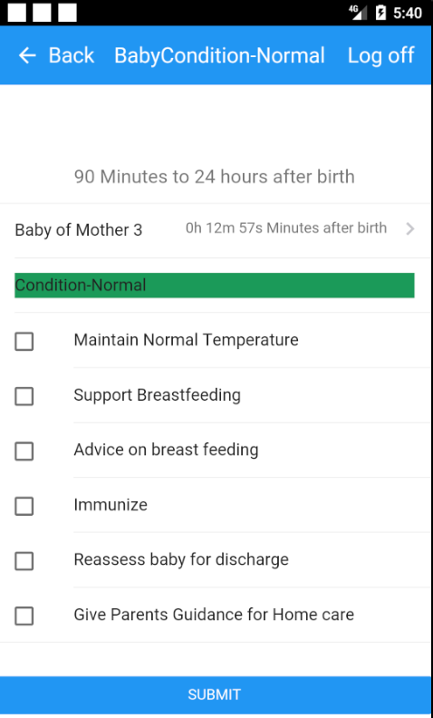

1. Normal condition page consists of the care to be given like maintaining normal temperature, support breastfeeding, advice on breastfeeding, immunize, reassess baby for discharge and give parents guidance for home care.
2. In the problem phase, the first condition is ‘Abnormal temperature’ which includes care like Improve thermal care, normal or requires continued thermal support. Normal consists of the same care to be given in ‘Normal’ condition of phase 3. Requires continued thermal support consists of prolong skin-to-skin care and inpatient care.
3. While ‘Under 2000g’ of problem stage consists of care like prolong skin-to-skin care and requires continued support (Inpatient care).

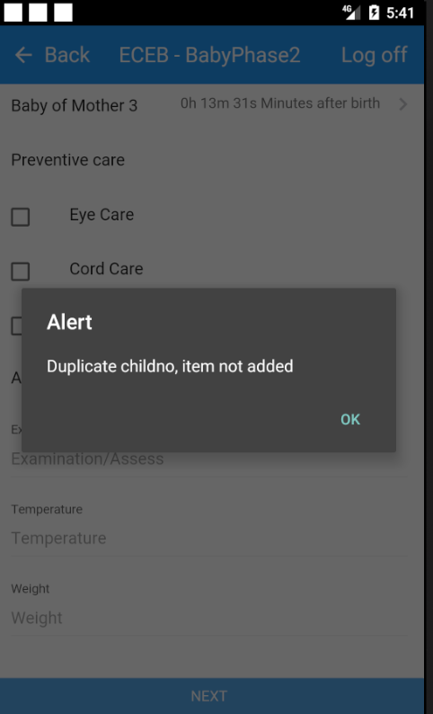 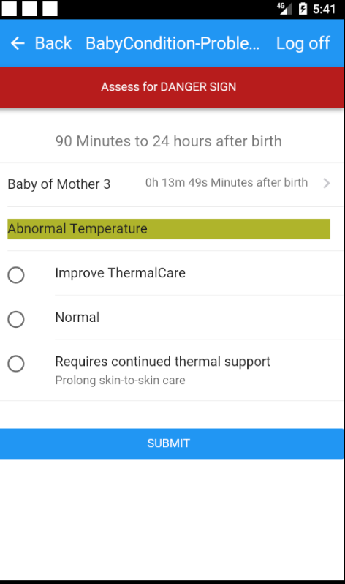 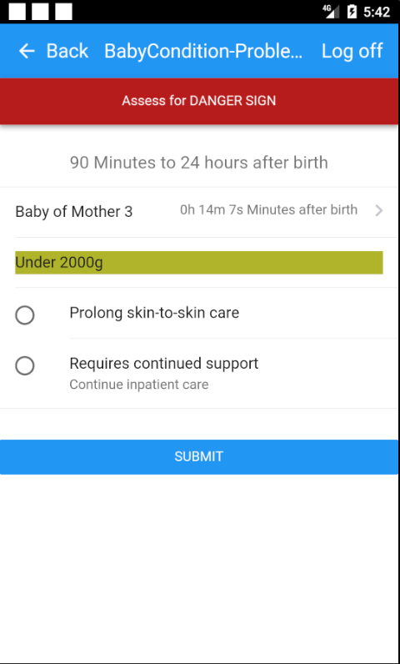

1. Moreover, ‘Poor feeding’ of problem stage consists of care like express breast milk, use alternate feeding method and requires continued support (Inpatient care).
2. Danger sign stage consists of conditions like Fast breathing, chest indrawing, temperature <35.50C or >37.50C, not feeding, no movement or convulsions. User could select one or multiple based on the baby condition.
3. Once after selecting the danger sign, there are options to prescribe antibiotics and seek advanced care.

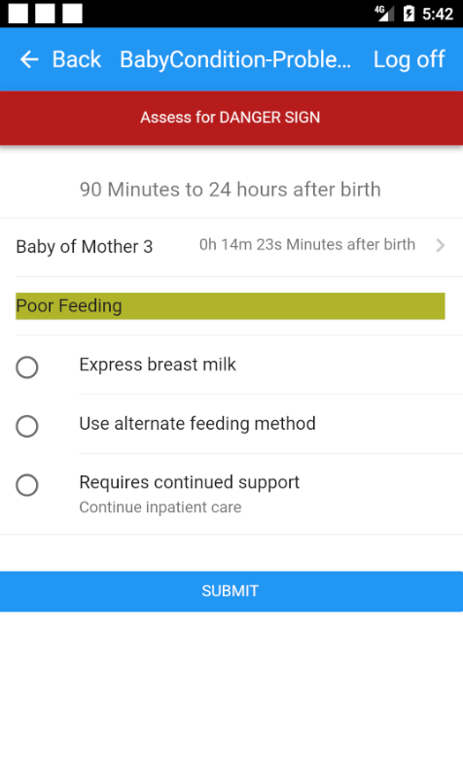 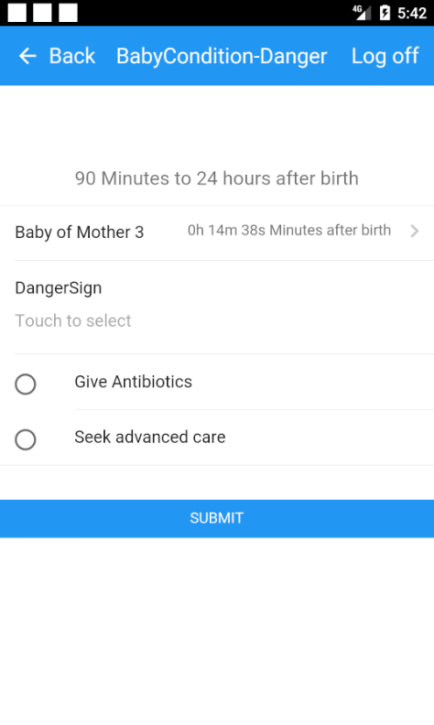 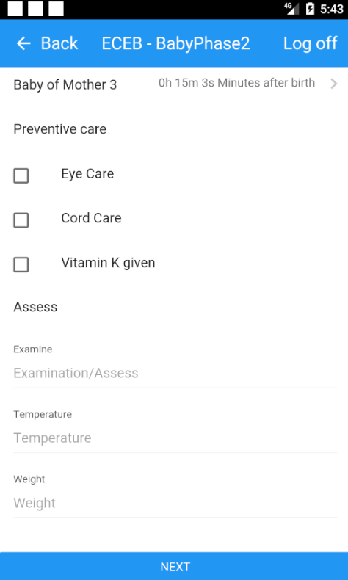

1. Another condition in danger sign is <1500g or severe jaundice which on clicking saves the data to local storage.

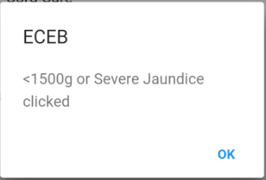

1. At the end of 24 hours there will be an alert asking for the user to enter details after which the submitted results will be stored in local storage.

The creation of the wireframe was done using Ionic 3.0, which is an open-source SDK for hybrid mobile app development. It was built on top of JS and Apache Cordova. It can be used to customize apps for Android and iOS. After building the app it was deployed through Cordova. The code was cloned to the GitHub repository named ‘eceb’ under the organization ‘iupui-soic’. Once after cloning the repository we need to enter the directory from the command line/terminal and executing ‘cordova run android’ will build our application specific ‘SDK’. Having an Android Studio installed on our desktop will launch the application using SDK generated in the emulator that has been created within Android studio.

After which the mobile application Icon was changed to appropriate picture. Thereafter, splash screens were added for both Android and iOS platforms. Using an Android Studio, I set up an Emulator to run the app after every stage of its development. Thereafter, application was built using ‘Cordova build’ and the performance of the app was assessed. The final step is studying the functionalities of the code present in src of the app folder to authorize login credentials of the application. After logging in a Logoff button at the top right corner helps the user to clear the saved login details and end the user session.

**Unique features of this mobile application are:**

1. Offline Push alerts: These are notifications that are sent using the Android notification system, but still work in offline mode and do not need data services. Clicking on the alert will direct the user to the appropriate phase.
2. ECEB Action Plan Algorithm: These reduce cognitive load on nurses and reminds them when a baby needs to receive specific care intervention.
3. Data Security: Once data is sent to DHIS2, at the end of 24 hours or discharge of the baby, all the details of the respective baby are deleted from the mobile application. This prevents ambiguity and makes the application user-friendly.

**Future work**

1. Sing-up and Facility login button needs to get functionality.
2. Saving details to mHBS2 needs to be done as the details are currently being saved to local storage.

**Conclusion**

From the study, I gained knowledge on creating wireframes, framework7, Cordova, HTML, JS and JQuery. This mobile application will be useful for providing care to the baby in areas where access to healthcare practitioners is limited and analyzing the quality of care given to the baby.

**Reference:**

1. Wang, Q., Egelandsdal, B., Amdam, G. V., Almli, V. L., & Oostindjer, M. (2016). Diet and Physical Activity Apps: Perceived Effectiveness by App Users. *JMIR Mhealth Uhealth, 4*(2), e33. doi:10.2196/mhealth.5114
2. Sobrinho, A., da Silva, L. D., Perkusich, A., Pinheiro, M. E., & Cunha, P. (2018). Design and evaluation of a mobile application to assist the self-monitoring of the chronic kidney disease in developing countries. *BMC Med Inform Decis Mak, 18*(1), 7. doi:10.1186/s12911-018-0587-9
3. Every NewBorn – an action plan to end preventable deaths (2014). World Health Organization. WHO press, Switzerland.
4. Essential Care for Every Baby. Retrieved October 13, 2018, from <https://www.aap.org/en-us/advocacy-and-policy/aap-health-initiatives/helping-babies-survive/Pages/Essential-Care-Every-Baby.aspx>